

Operational Environmental

Management Plan

Galong, NSW

CONTENTS
GLOSSARY 4
1 PURPOSE 5
2 SCOPE 5
3 DOCUMENT APPROVAL 5
4 REFERENCES 5
4.1 Internal Documents 5
4.2 External Documents 5
5 CONDITIONS OF APPROVAL 6
7 TARGETS AND KEY PERFORMANCE INDICATORS 9
8 ROLES AND RESPONSIBILITY 10
10 LAND USE MANAGEMENT 11
10.1 Scope 11
10.2 Objectives 11
10.3 Ecology 11
10.3.1 Flora 11
10.3.2 Vegetation Clearing 11
10.3.3 Fauna 12
10.4 Chemical Storage 12
10.5 Heritage 13
10.5.1 Aboriginal Heritage 13
10.5.2 European Heritage 13
10.6 Soil Management 13
10.7 Rehabilitation 13
10.8 Spill Management 14
10.9 Traffic and transport 14
11 WATER MANAGEMENT 15
11.1 Purpose 15
11.2 Scope 15
11.3 Environmental Risk 15
11.4 Surface Water 15
11.4.1 Southern Catchment 15
11.4.2 Northern Catchment 15
11.4.3 Other Water Supplies and Utilisation 16
11.4.4 Additional coal storage area 16
11.5 Groundwater 16
11.6 Surrounding Water Use 16
11.7 Control Measures 16
11.8 Inspections and Audits 17
11.9 Water Monitoring Program 17
11.9.1 Surface Water Monitoring Program 17
11.9.2 Groundwater Monitoring Program 18
11.9.3 Water Consumption Monitoring Program 18
11.10 Reporting 18
13 AIR QUALITY MANAGEMENT 20
13.1 Purpose 20
13.2 Scope 20
13.3 Background 20
13.4 Monitoring 20
13.5 Concentration Limits 21
13.6 Key Hazards & Risks 22
13.7 Control Measures 22
15 NOISE AND VIBRATION MANAGEMENT 23
15.1 Purpose 23
15.2 Scope 23
15.3 Background noise levels 23
15.4 Surrounding land use 23
15.5 Key Hazards & Risks 23
15.6 Control Measures 24
15.7 Monitoring 24
15.7.1 Inspections and Audits 24
15.7.2 Noise and Vibration Monitoring 24
15.8 Reporting 25
16 WEED & PEST MANAGEMENT 26
16.1 Purpose 26
16.2 Scope 26
16.3 Feral Animal Management 26
16.4 Weed Management 26
17 WASTE MANAGEMENT 27
17.1 Purpose 27
17.2 Scope 27
17.3 Waste Inventory 27
17.4 The Waste Hierarchy 27
17.5 Control Measures 37
17.1 Monitoring 38
17.2 Reporting 39
18 ENVIRONMENTAL ENHANCEMENT STRATEGY 40
18.1 Purpose 40
18.2 Scope 40
18.3 Procedure 40
19 INCIDENTS, COMPLAINTS AND REGULATORY BREACHES 41
19.1 Incidents 41
19.2 Emergency Response 41
19.3 Complaints 41
19.4 Regulatory Breach 42
20 CHANGES TO OPERATION 43
21 TRAINING 44
22 REVIEW 45
Appendix A – Vegetation Mapping 46
Appendix B – Water Retention, Chemical Storage and Possible Pollutants 47
Appendix C – Areas Of Weeds 48
Appendix D – Site Plan 49
Appendix E – Monitoring Positions 50

GLOSSARY
AHD | Australian Height Datum
Aquifer | A saturated permeable unit of rock or soil which is able to transmit significant quantities of water under ordinary hydraulic gradients
Clean Water | Water from undisturbed vegetated parts of the site. Clean water also includes collected rainwater and mains water
Contaminated Water | Water containing potential contaminants or pollutants
CWP | Company Wide Procedure KPI – Key Performance Indicator
DA | Development Approval
DCCEEW | NSW Department of Climate Change, Energy, the Environment and Water
Dirty water | Water from disturbed but otherwise uncontaminated parts of the site
DPHI | NSW Department of Planning, Housing, and Infrastructure
DPIRD | NSW Department of Primary Industries and Regional Development
ECATS | Environmental Compliance Action Tracking System
EPL | Environmental Protection Licence
Ground Water | Water that occurs beneath the water table in rock or soil that is fully saturated.
HSE | Health Safety and Environment
JDE | Site Action Management System
NSW EPA | NSW Environmental Protection Authority
PIRMP | Pollution Incident Response Management Plan
Surface Water | Water in a watercourse, lake, or wetland, or any water flowing over land
WAL | Water Access Licence

PURPOSE
The purpose of this document is to detail an environmental management framework for activities resulting from the influence of mining and associate operational activities.

SCOPE
This Plan covers the Galong Limestone mine. This plan applies to all owned and leased operational and non-operational properties. This plan therefore applies to the following land:
Table 1 – Land to which this Plan applies
Land description | Tenure | Area (ha)
Mining Lease (ML) No 1496 | Leased | 160 ha
Mining Lease (ML) No 1745 | Leased | 43.43 ha

DOCUMENT APPROVAL
Rev | Date | Prepared By | Reviewed By | Approved By
0 | July 2018 | David Lale | Ian Oppy | Steve D’Souza
1 | Dec 2020 | Colin Mitchell- Harries |  | Sylvio Livolsi
2 | Nov 2022 | Nicole Sullivan – HSE  Specialist | Wayne Trenning  Don Cheong
3 | March 2023 | Don Cheong | Nicole Sullivan | Wayne Trenning
4 | Dec 2024 | Gabrielle Head | Romin Nejad  Anna Butler | Wayne Trenning

REFERENCES

Internal Documents
  - Graymont Health, Safety and Environmental Policy
  - Graymont Environmental Sustainability Strategy
  - Galong Limestone Mine Forward Program 2025 - 2027
  - Rehabilitation Management Plan 2022
  - Emergency Management Plan 642-P10.201.01
  - BushFire Management Plan

External Documents
  - Statement of Environmental Effects, Galong Project 320 2015
  - EPA POEO Environmental Protection Licence Galong 4660
  - Australian Water Quality Guidelines for Fresh and Marine Waters (Australian and New Zealand Environment and Conservation Council (ANZECC), 2000).
  - Aquaterra “Hydrogeological Review for the Galong Limestone Mine” 13 October 2009

CONDITIONS OF APPROVAL
All legislation and regulations associated with site operations are included in the sites legal register.
The following table identifies specific conditions of approval and their corresponding requirements relevant to site operations in relation to land use management.
Consents, Leases, Approvals and Licences
Table 2 – Applicable Conditions of Approval
Relevant Approval | Issuing / Responsible Authority | Relevant Condition
Mining Lease 1496 | Department of Primary Industries and Regional Development (DPIRD) | Approval: 16 November 2001. Renewal: 15 November 2043  Section 2 – mining operations to be conducted in accordance with a Mining Operations Plan (MOP), which identifies specific land use activities. The Plan details the site’s water management systems.  Section 12(a) – rehabilitation of disturbed land as per the MOP.  Section 12(b) – storage of topsoil.  Section 14 – activities that pollute as per the MOP and regulator approval.  Section 16 – fencing and gates owned by landholders. Section 18 – access tracks.  Section 19 – vegetation clearing.
Mining Lease 1745 | DPIRD | Approval: 21 October 2016. Renewal: 21 October 2037  Section 2 – rehabilitation of disturbed land as per the MOP.  Section 3 - The lease holder must comply with an approved Mining Operations Plan (MOP) in carrying out any significant surface disturbing activities, including mining operations, mining purposes and prospecting.  Section 3.b Identify the post mining land use and set out a detailed rehabilitation strategy  Section 3(f) – preparation of a Rehabilitation Report Section 4 – preparation of a Compliance Report
DA (03-025) Limestone mine and processing  To alter the existing area of mining operations. The expansion of the mine and increased production for a period of forty (40) years, the consent allows for the production of 500,000tpa limestone for forty (40) years and the transport of 200,000tpa of crushed and processed limestone product including lime along designed transport routes. | Hilltops Council | Approval: 17 December 2003. Expiry: 16 Dec 2043  Section 5 – implement measures to minimise harm to the environment.  Section 20 – site boundaries identification. Section 24 – heritage.  Section 25 – vegetation clearing as per the Native Vegetation Conservation Act 1997 and the Mining Act 1992.  Section 37 – a plan of management for noxious weeds. Sections 39 to 42, 53 to 58, 62 & 63 – rehabilitation.  Section 44 – feral animal management.  Sections 45 to 51 - Aboriginal heritage  Sections 52, 59 to 61 – vegetation clearing.
DAT.03-025 Mod 3 issued 15/07/2015 |  | The site will undertake groundwater monitoring, including standing water levels using a piezometer.
Increased dispatch limits to allow a maximum of 310,000 tonnes to be transported on haulage routes.
DA T2003-025 Mod 4 | Hilltops Council | To increase dispatch limits and modification to haulage routes  Date of Consent: 27 March 2019
DA T.03-025 Mod 5 issued 27/9/20221 | Hilltops Council | Clarification of the use of approved mobile crushing plants on site.  Date of Consent: 27 September 2022
DA2020/0208 | Hilltops Council | Solar Energy System (1MW)  Consent to Operate: 27 April 2021  Consent to Lapse: 27 April 2026
Development Application  317-7-2003-i  For the construction and operation of a limestone kiln to produce 200,000tpa of quicklime.  DA 317-7-2003-I Mod 6 issued 06/08/2024  To extend the end date of the temporary 10,000 t Coal Stockpile and reducing vehicle movement | NSW Department of Planning, Housing, and Infrastructure (DPHI) | Approval: 11 December 2003  For the construction and operation of a limestone kiln to produce 200,000tpa of quicklime.  The construction and use of surface water detention/storage basins to collect surface water run-off.  Site will undertake water quality monitoring activities.  Condition 6.3, 6.5 – Consultation re preparation of the OEMP with the Department & EPA.  Multiple emails and recommendations on file re previous submissions on file e.g. EPL 4660, AEMR review and feedback  Mod 6  Removal of Condition 3.25A, decreasing coal haulage to a maximum of 6 heavy vehicle movements per day  Coal stockpile depletion by 30 June 2026
Complying Development Certificate  CD 04- 2017 | Hilltops Council | The upgrade of processing equipment to produce Hydrated lime. Processing equipment to be upgraded includes the following:  Hydrator plant & building Material transfer equipment  Storage silos x 6 Bagging plant & packaging equipment Weighbridge  Approval: 11 September 2017  Expiry: 11 September 2022
Complying Development Certificate  CDC2025/0006 | Hilltops Council | Coal Storage Facility  Approval: 31 March 2025  Expiry: 31 March 2030
Complying Development Certificate  CDC2025/0031 | Hilltops Council | Construction and operation of dry storage shed  Approval: 15 August 2025  Expiry:15 August 2030
OSM 479  Approval to operate | Hilltops Council | Approval: 13 October 2016 Expiry: TBA – Awaiting Council  An onsite wastewater management system (WWMS)  Sewage is collected in an aerated septic sewer system and treated wastewater is reused on site for irrigation. If it is unable to be used it is pumped out by a license waste disposal contractor on an as need basis.
Environmental Protection Licence No. 4660 | NSW EPA | Condition 2 Discharges to air and application to land - P1 Location of monitoring/discharge points and areas  Condition 3 Limit conditions – L1 Pollution of waters L2 Load Limits  L3 Concentration Limits L4 Noise Limits  L5 Blasting  Condition 5 Monitoring and recording conditions - M1 Monitoring records  Condition 6 Reporting conditions
WAL 30047  Water Access Licence | NSW Department of Climate Change, Energy, the Environment and Water (DCCEEW) | Issued: 7 June 2013  Category: Aquifer Share Component:  Share – 157 Units  Written records are required to log water usage. The maximum amount of water extracted will not exceed the documented share volume.
40CA411901  Water Supply Works & Water Use Approval. | DCCEEW | This approval relates to WAL 30047 and is attached to Lot 101 and 102, DP1083781  This approval provides extraction form the pit and bore 1 &2. Note that pit water is combined surface and groundwater  Issued: 16 January 2012  Expires: 15 January 2035
WAL 28703  Water Access Licence | DCCEEW | Issued: 16 January 2012  Expiry: 15 January 2035
40CA411879  Water Supply Works & Water Use Approval | DCCEEW | This approval relates to WAL 28703 and is attached to Lot 102, DP1083781  Issued: 16 January 2012  Expires: 15 January 2035
U6-95313/07/0  LPG Tanks Cert. Of  Plant Item  Registration | SafeWork NSW | Registration is renewed annually. This process is the responsibility of the tank’s controller, Elgas Ltd.

Table 3 – Applicable Legislation
Relevant Approval | Relevant Sections
Protection of the Environment Operations Act 1997 | Section 142A – pollution of land is an offence.
NSW Contaminated Land Management Act 1997 | Sections 60(1), 60(2) & 60(3) – notification of EPA if contamination of land has occurred.
NSW Local Land Services Act 2013 | Part 5a Land Management (native vegetation) Division 5, 6
NSW Biosecurity Act 2015 | Section 13 - Biosecurity Impact  Division 3 – Part 3 – general biosecurity duty Schedule 1
National Parks and Wildlife Act 1974 | Sections 86 & 89A – Aboriginal heritage. Section 98(2) – harming protected fauna. Section 112 – harming of snakes.  Section 117(1) – possession of protected native plants.  Section 118(1) & (2) – harming endangered or threatened species.  Section 118C and D – damage to habitat of endangered species.
Heritage Act 1977 | Section 139(1)&(2) - Excavation permit required in certain circumstances.
NSW Biodiversity Conservation Act 2016 | Division 1 - Offences
Environment Protection and Biodiversity Conservation Act 1999 | Section 18 – impacts on threatened species or endangered communities.  Section 20 – impact on migratory species.  Section 196(1) – impacts on threatened species or communities
Aboriginal and Torres Strait Islander Heritage (Interim Protection) Amendment Act 1986 | Section 20(1) – discovery of Aboriginal remains. Section 22 – significant Aboriginal areas.

TARGETS AND KEY PERFORMANCE INDICATORS
Information collected via monitoring will be used to verify compliance with the following targets, KPI’s and legal requirements and assess impacts on the local environment. Targets have been set to either comply with relevant legal requirements and/or to strive for continuous improvement in site operations. Targets and KPI’s have been set in accordance with the Company Wide Procedure – EHS Objectives, Targets, Plans and Performance Measures.
The following KPI’s are used to measure environmental performance against the targets stated in the table below:
Table 4 - Environmental Management and Key Performance (KPIs)
Target | Key Performance Indicator
Land Use
Vegetation in the rehabilitated areas is consistent with native vegetation communities of the surrounding environment. | Fixed monitoring plots in rehabilitation areas are characteristic of the target native vegetation communities.
Achieve an 80% success rate of rehabilitation | Monitoring of rehabilitation areas, comparing successful rehabilitation versus unsuccessful rehabilitation, noting the success rate.
No reduction in the number or loss of key flora species | Compare past site wide vegetation surveys to the current survey undertaken to determine if key flora species densities are being maintained.
Water Management
The yearly extraction limit of water does not exceed 307 mega litres (ML) (as per WAL 30047). | Recording the quarterly water consumption and ensure that it does not exceed 307 ML annually.
Performing the monthly surface water sampling in accordance with the EPL (No. 4660) | Each surface water monitoring event undertaken is recorded and presented in a report within the monthly time frame.
Groundwater level monitoring occurs quarterly | Groundwater levels are recorded and presented in a quarterly report
Waste Management
10% of solid waste is recycled from site | Measuring total volume of solid waste produced and the volume of solid waste recycled and noting the percentage of waste being recycled from the site
10% reduction of waste per tonne of product produced | Total volume of all waste produced on site (refer to Section 13.7 for waste monitoring) divided by total volume of product produced over 12 months
Achieve at least two onsite waste avoidance, reuse, or recycling initiatives per year | Describe the waste initiatives that are being undertaken on site in the quarterly Environmental Program Report.
Noise & Vibration
No breaches of licence condition 4 & 5 (EPL No. 4660) | Noise & blast monitoring results does not exceed the limits of EPL No. 4660 condition 4 and 5
Zero community complaints regarding noise and vibration in the local environment | Number of confirmed complaints received and logged in Graymont’s environmental incident reporting system related to noise and vibration
All ambient noise monitoring results to meet the NSW Industrial Noise Policy ambient noise criteria | Number of exceedances of noise criteria from NSW Industrial Noise Policy of ambient noise monitoring results

ROLES AND RESPONSIBILITY
The following people are the key Graymont roles responsible for the implementation and review of this Management Plan.
Table 5 – Key Roles
Role | Summary of Responsibility
Plant Manager | - Ensure the implementation of all control, monitoring and reporting measures as specified in this Plan  - Ensure a risk assessment is undertaken prior to commencing works  - Ensure compliance with Conditions of Approval  - Participate in the annual review of the Plan  - Approve amendments to the Plan  - Communicate the requirements of this plan to all personnel and contractors working at the site  - Consult with State Environmental Advisor regarding communication with government agencies.
HSE Specialist | - Put systems in place to implement the controls, monitoring and reporting measures specified in this Plan  - Conduct inspections, monitoring and reporting as per this Plan  - Identify and report on any actual or potential non-conformance with this Plan  - Undertake the required monitoring as detailed in this Plan  - Review monitoring results and report any non-compliances to the Plant Manager and the Environment Manager (Northern)  - Investigate any non-compliance with this plan and report findings and corrective actions to the Plant Manager and the Environment Manager (Northern)  - Participate in the annual review of the Plan.
Director of Operations (Northern) | - Ensure performance targets specified in this plan are being met  - Participate in the annual review of the Plan where required  - Consult with Environment Manager (Northern) regarding communication with government agencies.
Environment Manager (Northern) | - Provide technical advice in the development and implementation of the Plan  - Participate in the annual review of the Plan  - Communicate with government agencies on environmental matters in consultation with the Operations and Regional Managers as required.
Mining Superintendent | - Undertaking the statutory function of quarry manager (as per Work Health and Safety (Mines and Petroleum Sites) Regulation 2022)
All Staff | - Understand the contents of the Plan  - Adhere to instructions in relation to the Plan as given by the HSE Specialist or Plant Manager  - Identify and report on any actual or potential non-conformance with this Plan.

LAND USE MANAGEMENT

Scope
This Plan covers the Galong Limestone mine site approach to land use management. This Plan applies to all owned and leased operational and non-operational properties.

Objectives
The objectives of this Plan are:
  - to undertake a strategic and integrated approach to land management that recognises the current and potential use of land to maximise environmental outcomes, economic return and maintain access to future resource
  - to protect historic, social, and cultural heritage items/aspects, flora and fauna and preserve biodiversity
  - to ensure rehabilitation is considered and incorporated throughout the design, development, operation, and closure of sites to optimise post closure social, environmental, and economic outcomes
  - where site contamination has occurred, properly identify and manage the contamination to protect the health and safety of personnel and the community and to minimise or eliminate environmental impact
  - to satisfy the Graymont Australia requirements outlined within the Company Wide Procedure for Land Management

Ecology

Flora
The vegetation surrounding the Galong limestone mine comprises three types of vegetation communities.
  - Highly modified pasture. This area is dominated by pasture improvement and cropping practices and therefore populated by introduced plant species. When the area is not under crop, plant species making up exotic grasses, legumes and weeds are found. Scattered communities of gum trees provide shelter for livestock.
  - Unimproved pasture. These areas are characterised by rock exposure and not suitable to pasture or cropping. Species found in this area are grasses (mainly Tall Speargrass and Redleg Grass), some exotic grass, legume and weed species. The area also comprises a mixture of gum trees.
  - Riparian zone community. Is the corridor found along Limestone Creek. The area comprises a combination of native and introduced grass species, as well as a mixture of gum trees.
There are no threatened plant species identified to occur on the site.
The site does contain remnant vegetation that can be described as representative of the following endangered ecological communities:
  - White Box, Yellow Box, Blakely’s Red Gum Woodland Community (NSW listing)
  - White Box, Yellow Box, Blakely’s Red Gum, Apple Box Community (Commonwealth listing)
Both communities have been assessed, it has been determined that no significant impact on any endangered ecological community would occur as a result of the activities at the site.
There are no threatened fauna species (NSW or Commonwealth listing) identified to occur on the site.
Native species located on the mining lease are protected from collection and removed from site, unless authorised by the site manager.
A vegetation map is attached as Appendix A – Vegetation Mapping.

Vegetation Clearing
Significant vegetation clearing of native populations can only be conducted with the prior approval from DPHI.

Fauna
The fauna status in the area corresponds closely to the three vegetation communities listed above.
The Improved pasture area is considered to be of low fauna value. The area has the occasional presence of kangaroos and supports a number of common bird, reptile, and amphibian species.
The unimproved pasture areas are considered small, disturbed, and unlikely to support significant fauna. The area is considered to be richer in fauna than improved pasture areas, due to the existence of food and habitat for some native species.
The riparian habitat centres along the main watercourse within the area, Limestone Creek. It provides an important corridor for fauna movement and foraging, shelter, nesting and roosting sites for birds, bats, terrestrial and arboreal animals, and invertebrates. Riparian vegetation within 20 metres of Limestone Creek will not be removed.

Chemical Storage
Apart from the fuel and gas storage facilities and general workshop materials there are no hazardous materials stored on site.
LPG Tank Storage
The gas used onsite for kiln start up and coal drying is stored in a 20,000ltrs LPG tank supplied by ELGAS Ltd. The LPG tank is installed and maintained in accordance with Australian Standards.
Diesel Tank Storage x 2
  - A 33, 950 litre diesel tank is located on a concrete slab adjacent to the workshop. The tank is double skinned and is self-bunded. The workshop has a sealed floor. The storage is designed and installed with reference to Work Cover’s Storage and Handling of Dangerous Goods, Code of Practice 2005 and in particular AS 1940-2004 – Storage and Handling of flammable and combustible liquids. Diesel will continue to be used on site.
  - An additional 67,000 litre diesel tank is located adjacent to the haul road in the mining area; the tank is double skinned and is self-bunded.
Coal Storage
Coal is currently stored on site in a covered, two-sided shed.
Current coal storage is 200 tonnes
See map attached as Appendix B – Water Retention, Chemical Storage and Possible Pollutants for Coal Storage areas on site.
The temporary storage of an additional 10,000t of coal was approved by the Department of Planning & Environment (DPE) (DA-317-7-2003-I MOD4, determined 29 March 2023). The coal stockpile and pad is currently being operated in accordance with the design detailed in the Graymont Galong Kiln MOD 4 Modification Report 221122. The temporary coal stockpile end date was extended from end of June 2024 until 30 June 2026, approved by the Department of Planning, Housing, and Infrastructure (DPHI) (formerly DPE) under DA-317-7-2003-I MOD 6. The coal stockpile design and mitigation measures address the requirements of MDG 28 Safety requirements for Coal Stockpiles and Reclaim Tunnels (NSW T&I, 2013), including the following:
  - Stockpile heigh limited to a nominal 2.5 m
  - Ramp designed to access the top level
  - Spontaneous combustion and fire risks will be mitigated by wind protection (2.5 m high boundary bunds), low stockpile height, construction method, good drainage, and access to top and sides.
  - Daily inspection
  - Coal stockpile work limited to times of good visibility
  - Operators working on the coal stockpile will be trained and competent
  - No hot work will be permitted on the coal stockpile
  - Stockpile footprint will be surveyed and clearly marked. Ramps will be clearly marked Additional environmental control measures for the coal storage are addressed in this OEMP.

Heritage

Aboriginal Heritage
The current approved area for mining has in the past been heavily impacted upon by agricultural practices. As such and when assessed it was determined that this area would be unlikely to contain any sites of Aboriginal heritage significance, as per the AHIM’s survey conducted in 2011.
The site has liaised with members of the Burfi Ngunwal Aboriginal Corporation and the Yass / Onerwal Aboriginal Land Council in accordance with Condition No 47 of DA T.03-025, representatives from relevant Aboriginal groups have monitored the removal of the top 50cm of topsoil and subsoil during pre-stripping operations.
For current and future works onsite, should any Aboriginal objects be uncovered during day-today operations, the work should cease and the NSW National Parks and Wildlife Service [NPWS] be contacted for advice. It is considered an offence to disturb or destroy Aboriginal objects without the permission of the Director-General NSW NPWS. All site personnel and contractors are to be aware of the above-mentioned expectations with regards to preserving Aboriginal heritage.

European Heritage
A historic well exists on the site just north of the present office and car park. Following discussions with relevant heritage groups and the Harden Shire Council, and regarding requirements under Condition 24 of DA T.03-025 the well area remains fenced, and the site preserved.

Soil Management
The following procedure will be implemented during land preparation:
- The Plant Manager will ensure that a risk assessment is undertaken prior to commencing works, identifying, and detailing the potential environmental and safety risks relating to clearing and clearing.
- The Mining Superintendent will ensure that personnel involved in the works are briefed on the risks and controls detailed in the risk assessment.
- Mining Superintendent will ensure that the limit of clearing (as shown in attachment 9) is delineated with pegs, fencing, or flagging tape.
- The Mining Superintendent will ensure that an inspection is undertaken prior to commencing clearing works within the area to be disturbed, to check for the presence of fauna or active nests. Fauna or active nests found will be relocated or encouraged to move from the area.
- The Mining Superintendent will ensure that topsoil (including vegetation) is stripped and stockpiled separately from subsoil.
- The Mining Superintendent will ensure that vegetation, topsoil, and subsoil is directly used for rehabilitation or stockpiled separately for future re-use.
- The Mining Superintendent will ensure that topsoil is stockpiled as follows:
    - 2m height maximum
    - handling of topsoil to be minimised
    - stockpile to be accessible for weed control
    - stockpile to be signposted to indicate the extent and nature of the material and to avoid disturbance
    - stockpile to be re-vegetated with suitable cover crop as described in section 4.5.1, in order to stabilise the soil and maintain biological processes
    - weeds on the stockpile will be routinely sprayed, as part of the site weed management program.
    - stockpile is to be signposted to indicate the extent and nature of material
- The Mining Superintendent will ensure appropriate erosion and sedimentation controls are implemented to protect stockpiles.

Rehabilitation
Galong has a comprehensive Rehabilitation Management Plan along with a supporting Forward Plan that is in place for the period 1 January 2025 to 31 December 2027.
Both the Forward Plan and the Management Plan outline what Galong will achieve in the rehabilitation area.

Spill Management
Galong has implemented a Pollution Incident Response Management Plan (PIRMP) which focuses on the management of pollution incidents at Galong.
The purpose of the PIRMP is to ensure site readiness in the event of a pollution incident or product spill. The PIRMP applies to all pollution incidents / product spills that occur at the site as a result of activities carried out by Graymont.
Summary of pollution response is as follows:
  - Stop work
  - Consider safety
  - Control
  - Contain
  - Notify/Report
  - Clean-up

Traffic and transport
Haulage of the additional 10,000 tonnes of coal will be undertaken within the hours of 7:00am and 7:00pm Monday to Saturday. A maximum of 6 heavy vehicle movements (3 in and 3 out) per day is permitted. Coal haulage will utilize the approved heavy vehicle haulage route south of Eubindal Road to the Galong/Burley Griffin Way intersection, via Eubindal Road, Galong Road, Ryan Street and Crescent Street.
During the haulage of the additional 10,000 tonnes of coal, the pavement condition between Burley Griffin Way and the Project site will be monitored to assess the potential impact of heavy vehicles on the road surface and remediate as needed. Periodic road inspections are undertaken. Hilltops Council is notified if any road remediation request is required.

WATER MANAGEMENT

Purpose
This plan outlines the site’s water management practices. It aims to specify the actions undertaken at Galong necessary to mitigate the impacts of site operations on water resources and to comply with legal and other obligations relating to water.

Scope
This Plan details the management of water at Galong, NSW and applies to all Graymont controlled activities for this site and covers all new developments, any construction activities, and onsite operations through to site closure.
The plan covers the following activities:
  - water extraction,
  - water harvesting,
  - dewatering,
  - transport,
  - water storage,
  - water usage (potable and process water),
  - impounded water
  - groundwater; and
  - erosion and sediment control

Environmental Risk
All environmental risks associated with site operations have been assessed in accordance with Graymont’s Risk Management Procedure. An environmental risk register has been developed which details the environmental risks associated with the impact on water resources.

Surface Water
The management of surface water and groundwater across the site is under review, to wholistically improve water management. Graymont continues to engage with the EPA on this improvement opportunity.

Southern Catchment
The former “Main Retention Dam” now with a permeable floor, functions as the Sediment Basin for the catchment of all water in the southern part of the mine site.
The larger Retention Basin (also constructed with a permeable floor) located to the north of the above Sediment Basin can hold 1 in 10-year ARI, 72-hour storm runoff (1.5 ML).
This basin is used to supply water for dust suppression and for the truck wash facility. Sediment from the truck wash facility collects in three underground tanks prior to water being returned into the Retention Basin. This basin operates with a working volume of 0.5 ML and has the capacity to hold.
1.5ML of storm water storage.

Northern Catchment
The northern catchment area drains towards the northern retention basin. A separate settlement basin was not constructed as originally proposed due primarily to agricultural limestone being stockpiled within the required basin area. The retention basin is constructed to meet the OEH-EPA criteria of a 1 in 10-year ARI 72-hour storm, with a capacity of 1.93 ML.
During 2011 sales of agricultural limestone ex-stockpile increased with a corresponding reduction in stockpiled material.

Other Water Supplies and Utilisation
Town water for potable and ablutions purposes is supplied via a polyethylene pipeline from a supply line alongside Eubindal Road. Two 371,000 L firefighting water tanks are located within the coal storage access road loop. The site’s water tanker can carry 30,000 litres.

Additional coal storage area
The stockpile pad for storage of additional 10,000 tonnes of coal was constructed with a drainage system and associated bunding to ensure that water flows to the south-east corner and is retained within the site’s existing water management system (refer to Figure F3-2, Graymont Galong Kiln MOD 4 Modification Report 221122).

Groundwater
The groundwater in the mine area is of low salinity.
The main water inflow to the open cut occurs from a natural fracture system.

Surrounding Water Use
The mine site is located within the catchment of Limestone Creek, which covers an area of approximately 38km², of which approximately 7.6km² is located upstream of the mine site. Limestone Creek joins with Rocky Ponds Creek 2km from the Project Site.
The groundwater that accumulates in the open-cut mine is of a quality suitable for irrigation purposes. Control Measures
The following table outlines the control measures which would be employed to ensure that extracted mine water is not mixed with potentially contaminated storm water. Frequency of inspection or maintenance has been determined based on risk.
Table 6 – Water Control Measures
Controls | Timing / Frequency | Evidence of Implementation
Mining services designed stockpile (stockpiling away from creek, designed drainage, vegetation cover) | Weekly | Mining Diary
Test of Pollution Incident Response Management Plan (PIRMP) | Annually | Environmental Compliance Action Tracking System (ECATS)
Erosion and sediment controls. | Ongoing | HSE Inspection
Water Meter Readings. | Monthly | Monthly Record
Spill Kits  Any spills to be immediately contained and absorbed with suitable material.  Checked for use and refill periodically | Periodically | HSE Checklist
Pit inspections | Daily | Mining Diary
Pre-start inspections | Daily | Pre-start checklists
Regular servicing of equipment | Ongoing | Service logs
Diesel Tank is self-bunded and bollarded. SDS Available | Ongoing | HSE inspections
Chemical storage is self-bunded. SDS is available | Ongoing | HSE inspections
Effluent storage pit. A licenced contractor used to pump pit out. | Biannually | Work records
Dams are suitably designed. Dams are desilted by site when headboard is reduced. | Ongoing | Work records

Inspections and Audits
The inspection and audit regime employed at the site has been detailed in Table 6. All corrective actions generated from these inspections and audits are to be entered into the site action management system, responsibilities assigned, actioned, and closed out within the specified time.
Table 7 – Inspection and Auditing Requirements
Description of Monitoring | Timing / Frequency | Inspection / Audit Tool:
An environmental site inspection of the premises will be conducted by site personnel as part of the EHS site inspection process. All control measures under this Plan will be assessed under this process. | Monthly | Site House Keeping Inspections
An environmental compliance audit will be conducted to determine statutory compliance with all approval and licence conditions. Compliance with this Management Plan will also be assessed. | Every three years | Site Environmental Audit template

Water Monitoring Program
The following section describes the site’s water monitoring program. The program is designed to qualify and quantify the extent to which the key objectives of this plan are being achieved. All monitoring is conducted by a suitably qualified/trained person.
Surface water and groundwater sampling and preservation of samples must be conducted in accordance with AS/NZS 5667 Water Quality - Sampling. A site-specific SOP exists for this task to ensure all safety and sampling requirements are met.

Surface Water Monitoring Program
All water quality samples are sent to a laboratory for analysis that is NATA accredited for the parameters listed in the following tables. Responsibilities for onsite water monitoring are detailed in Section 7.
Surface water within the site flows predominantly towards Limestone Creek. The water is intercepted by 2 sediment basins during high rainfall events. Water sampling of 4 points located both on and off site is conducted monthly. Sites are indicated in Appendix F
Table 8 – Surface Water Monitoring Program
ID. | Location | Purpose | Frequency | Parameters | Sampling Method
A (off site) | Top of creek | Upstream water quality | Monthly | pH Conductivity  Total Dissolved Solids  Dissolved Iron  Dissolved Zinc  Dissolved Copper  Dissolved  Cadmium  Dissolved Lead  Nitrates  Orthophosphorous  T.Kjel.N (calc)  Total Oil and Grease  Total Nitrogen | Grab Sample
B (on site) | Pit | Water quality on site. | Monthly |  | Grab Sample
C (off site) | Bottom of creek | Downstream water quality | Monthly |  | Grab Sample
D (on site) | Settling dam | Water quality on site | Monthly |  | Grab Sample

Routine monitoring of surface and pit water is conducted to determine historical trends for quality changes / comparative purposes
DA 317 notes the licence requirements for an old “take and use” licence. This relates to taking and using water. The old licence had limits however did not relate to the licence scope. The changes to water licence management from a “take and use” licence to WAL 30047 automatically removed the limits as they were not applicable.

Groundwater Monitoring Program
Groundwater monitoring is based on an observation of groundwater levels using a piezometer. There is no requirement to monitor the water quality of the boreholes due to the generally stable baseline water quality within the mine. Regional northerly trending groundwater flow in the limestone aquifer is locally disrupted by pit dewatering in the quarry.
The monitoring of groundwater expands understanding of water sources for the pit. Review of information shows the percentage of surface and groundwater contributions to the pit water volumes
The licence sets limits for groundwater extraction via water in the pit sump, however the surface water
% contribution of pit water does not contribute to the annual extraction limit.
Table 9 – Groundwater Monitoring Program
Bore Id. | Aquifer | Purpose | Frequency | Parameters
P1, P1a, P2, P3, P5, P8, and P9 | Limestone Aquifer | Groundwater Level | Quarterly | Water level in millimetres

Water Consumption Monitoring Program
The site has a program in place to monitor water usage from water pumped from the pit. The water gauges in place monitor the amount of water pumped out of the pit and consumed on site and the amount of water being pumped to Bobbara station for agricultural use.
Table 10 – Water Consumption Monitoring Locations
Description of Monitoring | Timing Frequency | Monitoring Method
Meter 1 (#58530) Line out of Pit | Quarterly | Physical Reading
Meter 2 (# 32802) Line to Bobbara Station | Quarterly | Physical Reading
Meter 3 (# 15284) Line to Creek | Quarterly | Physical Reading
Meter 5 (#62744) Laydown Yard | Quarterly | Physical Reading
Bobbara Town Water (#3378) | Quarterly | Physical Reading

Reporting
Management at site have a responsibility to submit periodic water reports as part of the sound environmental management of the site and the surrounding areas. This allows the site to provide operational updates on activities that have the potential to affect the environment.
The following table provides a summary on the site’s relevant reporting requirements:
Table 11 – Water Reporting Requirements
Description of Reporting | Frequency of Reporting | Reporting Tool | Receiving Body
Annual Return for Environment Protection Licence | Annually | Online Annual Return Template | EPA
Water-related complaints and environmental incidents | Immediate | ECATS | As per Graymont incident notification and investigation procedure
Annual Rehabilitation Report and Forward Program | Annually | Online portal | Resources Regulator
Annual Review | Annually | Documented Report | Department of Planning, Housing and Infrastructure (circulation also to Hilltops Council and Environment Protection Authority)

AIR QUALITY MANAGEMENT

Purpose
This section of the Plan outlines the site’s air quality monitoring requirements. It aims to specify the actions undertaken at Galong necessary to mitigate the impacts of site operations on air quality and to comply with legal and other obligations.

Scope
This Plan details the management of air quality at Galong, NSW and applies to all Graymont controlled activities for this site and covers all new developments, any construction activities, and onsite operations through to site closure.

Background
The EPA advised site of proposed licence variation conditions to (EPL 4660) in December 2015 regarding the submission by Sibelco to modify DA 317-7-2003i (Mod 3) – (operation of lime kiln).
The main intent of the licence variation was to ensure that the new licence conditions reflected standards contained in Part 5 of the Protection of the Environment Operations (Clean Air) Regulation 2010 with regards to in-stack emission limits for industrial activities in NSW.
In May 2016, the EPA issued Notice of Licence Variation No. 1535156. The Notice made the following changes:
  - Licence to permit operations of the refurbished lime kiln to resume
  - Re-introduction or air emission monitoring requirements
No variation to the licence was required for Hydrator operation. As per the EPA letter dated 12.7.2018, initial emissions testing post commissioning is required to ensure OEM performance standard of 10mg/m3. Further emission testing for 2 years to ensure continued compliance to 10mg/m3.
Any non-conformance requires corrective action.

Monitoring
The points referred to in the table below are identified in Galong - 4660 - POEO Licence (version 1 August 2025) for the purposes of monitoring and/or the setting of limits for the emission of pollutants to the air from the point.
Table 12 – Location of monitoring/discharge points and areas
EPA ID # | Type of Monitoring Point | Type of Discharge Point | Location Description
1 | Air emission monitoring | Discharge to Air | Lime kiln stack
2 | Air emission monitoring | Discharge to Air | Coal Mill exhaust
3 | Dust monitoring | None – deposition station | Dust monitoring gauge labelled "DG1" on the plan titled "Galong Limestone Mine and Kiln Plan 1 - Dust Monitoring Gauge Locations", dated June 2010 (DOC10/31773).
4 | Dust monitoring | None – deposition station | Dust monitoring gauge labelled "DG2" on the plan titled "Galong Limestone Mine and Kiln Plan 1 - Dust Monitoring Gauge Locations", dated June 2010 (DOC10/31773).
5 | Dust monitoring | None – deposition station | Dust monitoring gauge labelled "DG3" on the plan titled "Galong Limestone Mine and Kiln Plan 1 - Dust Monitoring Gauge Locations", dated June 2010 (DOC10/31773).
6 | Dust monitoring | None – deposition station | Dust monitoring gauge labelled "DG4" on the plan titled "Galong Limestone Mine and Kiln Plan 1 - Dust Monitoring Gauge Locations", dated June 2010 (DOC10/31773).

Concentration Limits
Table 13 – Air Concentration limits as per EPL 4660
Monitoring Point | Pollutant | Units of measure | 100 percentile concentration limit | Reference conditions | Oxygen correction | Averaging period | Frequency
1 | Solid Particles | mg / m3 | 100 | Dry, 273K, 101.3 kPa | 7% | TM 16 | Yearly
1 | Nitrogen Oxides | mg / m3 | 2000 | Dry, 273K, 101.3 kPa | 7% | TM 11 | Yearly
1 | Total Fluoride | mg / m3 | 50 | Dry, 273K, 101.3 kPa | 7% | TM 9 | Yearly
1 | Dry Gas Density | Kg / m3 | * | - - - | - - - | TM 23 | Yearly
1 | Lead | mg / m3 | * | - - - | - - - | TM 12, 13, 14 | Yearly
1 | Mercury | mg / m3 | * | - - - | - - - | TM 12, 13, 14 | Yearly
1 | Moisture | % | * | - - - | - - - | TM 22 | Yearly
1 | Molecular weight of stack gasses | g / g mole | * | - - - | - - - | TM 23 | Yearly
1 | Oxygen (O2) | % | * | - - - | - - - | TM 25 | Yearly
1 | Sulphur Oxides | mg / m3 | * | - - - | - - - | TM 4 | Yearly
1 | Temperature | °C | * | - - - | - - - | TM 2 | Yearly
1 | Velocity | m / s | * | - - - | - - - | TM 2 | Yearly
1 | Volumetric Flow Rate | m3 /s | * | - - - | - - - | TM 2 | Yearly
2 | Solid Particles | mg / m3 | 100 | Dry, 272K, 101.3 kPa | NA | TM 15 | Yearly
3,4,5,6 | Particulates – Deposited Matter | g / m2 / month | NA** | - - - | NA | AM 19 | Monthly
* - No EPL limit
** Comparison against EPA criterion of 4 g/m2.month, which is as an annual average for an acceptable level of deposited dust, measured as insoluble solids.

Key Hazards & Risks
The following activities (hazards) pose a medium to high risk to the environment and the community from environmental emissions and fugitive dusts.
Table 14 – Key risks associated with site environmental emissions and fugitive dust
Activity (Hazard) | Risk
Product crushing, screening, and milling | Fugitive dusts leaving site resulting in exceedance of deposited dust levels at sensitive receivers
Product handling and stockpiling
Blasting
Road trucks hauling product through Galong Village | Product deposited on road trucks falling / blowing off resulting in nuisance dust from vehicles moving through Galong village
Kiln Operation | Kiln emissions exceed licence limits
Coal Milling Operation | Coal mill emissions exceed licence limits
Hydrator operation | Dust collector operation do not conform to manufacturers OEM specification resulting in licence parameters being set for Hydrator emissions

Control Measures
The proposed controls to mitigate the potential risks from the hazards listed above are outlined in the table below. The frequency of each control and the records that are maintained to demonstrate that the control is implemented is also provided. The temporary coal stockpile is uncovered and contains ramps to allow watering to reduce dust and provide access.
Table 15 – Environmental emissions and fugitive dust control measures
Controls | Timing / Frequency | Evidence of Implementation
Maintain all dust collectors on site to ensure operating efficiently | As per maintenance schedule | Maintenance log
Maintain kiln operation parameters to ensure operating efficiently | As per Maertz recommendations | Operators log
Watering of site internal roads | Daily as required | Pre-start checks noting Water truck operation hours  Operational efficiency tracking of mobile plant
Stack emission testing:  Kiln  Coal Mill | Annually | Stack emission testing reports Publication of emission results on Graymont website
Stack Emission testing:  - Hydrator | Annually for 3 years | As per EPA letter dated 12.7.2018  Initial emissions testing post commissioning to ensure OEM performance standard of 10mg/m3  Further emission testing for 2 years to ensure continued compliance to 10mg/m3.  Results to be submitted via ARR

NOISE AND VIBRATION MANAGEMENT

Purpose
The objectives of this section relating to Environmental Noise and Vibration Management is to outline how site will eliminate or minimise material and non-trivial noise and vibration from Graymont’s operations and their potential impacts on the environment and the community.

Scope
This Plan covers the environmental risk of environmental noise and vibration generated from activities conducted on this site. The Plan applies to all material and non-trivial environmental noise and vibration emissions resulting from all Graymont controlled activities and covers onsite operations through to site closure. This Plan does not cover the Occupational Health and Safety hazards and risks from noise and vibration onsite. These hazards and risks are covered by the Key Risk Requirement for Occupational Noise Exposures and associated legislation.

Background noise levels
Heggies Australia were commissioned to conduct compliance monitoring for the Galong Kiln operation in 2005 to determine compliance to the Development Consent DAT03-025. In 2015 SLR were commissioned to conduct a noise impact assessment for the proposed change in quarry product despatch volume to 320,000t/yr. In 2018 SLR were commissioned to conduct a noise impact assessment for the proposed change in quarry product despatch volume to 430,000t/yr.

Surrounding land use
The surrounding land use is predominantly rural agriculture. Galong village is 4.3 km distance (direct line to the nearest dwelling).
Table 16 – Description of surrounding land use and sensitive receptors
Direction (N/S/E/W) | Description of resident, business, activity, land use? | Sensitive Receptor (Yes/No)? | Distance from premises (km) | Issues (if applicable)?
NW | Farmhouse Eubindal road | Yes | 2.3 | Blast monitoring point
NNW | Farmhouse Eubindal road | Yes | 3.2
S | Farmhouse Bobbara road | Yes | 3.4
W | House Galong | Yes | 4.3 | Closest house on Ryan St Galong
W | Houses Galong | Yes | 4.4 | Houses along Ryan St Galong
SE | Farmhouse Armours road | No | 4.5
E | Farmhouse Hughstonia road | No | 4.7
NW | St Clements Monastery Kalangan Road | Yes | 5.7

Key Hazards & Risks
The following activities (hazards) pose a medium to high risk to the environment and the community from environmental noise and vibration.
Table 17 – Key risks associated with site environmental noise and vibration
Activity (Hazard) | Risk
Product crushing, screening, and milling | Exceedance of noise levels at sensitive receivers
Blasting | Causing structural damage to third party property from ground vibrations
Road trucks hauling product through Galong Village | Excessive speed of road trucks resulting in increased noise from vehicles moving through Galong village

Control Measures
The proposed controls to mitigate the potential risks from the hazards listed above are outlined in the table below. The frequency of each control and the records that are maintained to demonstrate that the control is implemented is also provided.
Table 18 – Environmental noise and vibration control measures
Controls | Timing / Frequency | Evidence of Implementation
Maintain equipment to ensure it is operating efficiently | As per maintenance schedule | Maintenance log
Notify local residents (sensitive receptors) and emergency services of blasting schedule | 2 days prior to blasting event | Via site entry road sign and email
Reduce vehicle speeds near sensitive receptors | Ongoing | Truck driver Induction training Speed advisory signs in 2 positions along Ryan St Galong
Acoustically treating affected dwellings in Galong | By end 2018 | Initial acoustic report  Interim and Final treatment reports for each dwelling

Monitoring
This section outlines the various modes of monitoring onsite to quantitatively track and observe environmental noise and vibration emanating from site.

Inspections and Audits
Table 19 – Inspection and auditing measures
Description of monitoring | Timing / Frequency | Inspection/audit tool
An environmental site inspection of the premises will be conducted by Site Personnel as part of the EHS site inspection process. All control measures under this Plan will be assessed under this process. | Monthly | Site EHS Inspection checklist
An environmental compliance audit will be conducted to determine statutory compliance with all approval and licence conditions. Compliance with this Management Plan will also be assessed. | Every three years | Environmental Audit report
All corrective actions generated from these inspections and audits are to be entered into the Site Action Management System, responsibilities assigned, actioned, and closed out within the specified time.

Noise and Vibration Monitoring
The following noise and vibration monitoring will be undertaken at the site.
Table 20 – Noise and vibration monitoring measures
Description of monitoring | Timing/ Frequency | Parameters | Monitoring Method
Blast monitoring at monitoring location Eubindal road as shown in appendix F | During blasting event | Air blast overpressure; Ground vibration levels (see Table 20) | via external blast contractor

Table 21 – Blast Management Criteria
Ground Vibration Peak Particle velocity* | Not to exceed 5mm/s for more than 5% of total blasts / reporting period | Not to exceed 10 mm/s at any time
Air Blast Overpressure level* | No to exceed 115 dB (Lin Peak) for more than 5% of total blasts / reporting period | Not to exceed 120 dB at any time
*At any residence or noise sensitive location that is not owned by the licensee

Reporting
The following table details the reporting requirements for environmental noise and vibration under this Plan.
Table 22 – Reporting Requirements – Environmental Noise and Vibration
Description of reporting | Frequency of reporting | Reporting tool | Reporting to:
Blast monitoring results as per EPA condition EPL 4660 L5 | Each blast | Graymont Monitoring data form | Graymont website
Annual Return including all relevant licensed based monitoring reports | Annually | Annual Return | NSW EPA
Annual Review | Annually | Annual Review report | Department of Planning, Housing and Infrastructure  NSW EPA  NSW Dept of Water
Noise and vibration complaints | Within 48 hours of occurring | ECATS | As per Graymont incident notification matrix
Noise and vibration related environmental incidents | Within 48 hours of occurring | ECATS | As per Graymont incident notification matrix

WEED & PEST MANAGEMENT

Purpose
This plan outlines the site’s weed and pest management practices. It aims to specify the actions undertaken at Galong necessary to mitigate the impacts of site operations on the local environment.

Scope
This section of the plan applies to controlling Of Weeds and Pests on the Galong site.

Feral Animal Management
White land snails are of a concern in the local area, and as such are regularly controlled. Options for control include:
  - Baiting with snail bait on a yearly basis, especially during mating season, following rain events, or as suggested by Local Land Services
  - Cool burning of affected grassed areas of the site.

Weed Management
In accordance with Condition No. 37 of Development Consent DA T.03-025 and Condition No. 6.46 of Development Consent DA-317-7-2003-i weed species need to be identified and a plan established for their management on site.
Weeds may be found on the following locations on site:
  - open grassy areas,
  - on the outside perimeter of structures,
  - underneath stairwells leading up to structures,
  - on banks and settling dam structures,
  - bund walls,
  - paddocks
  - overburden emplacements,
  - soil stockpiles
Under consultation from the Southern Slopes Noxious Plants Authority ten weed species have been identified that surround the Galong Limestone Mine, and include the following:
  - Scotch Thistle (5 HA) St John’s Wort (<1HA)
  - Tree of Heaven (<1HA) Wild Radish (<1HA)
  - Slender Thistle Variegated Thistle
  - Horehound Paterson‘s Curse
  - Californian Thistle Narrawa Burr
To avoid propagation of weed species, routine weed control is undertaken in the above-stated areas on site. Weed control is undertaken by chemical spraying. Spraying should be targeted in early Autumn and in early Spring.
Local Pest & Weed Control contractors are contacted to attend site to spray weeds and check pest and rodent baits on a regular basis until weed and pest control is effective.
Galong personnel will be responsible for weed management and all personnel involved in this task will be certified and hold a current Chem Cert qualification.
A plan of areas of weeds is detailed in Appendix D.

WASTE MANAGEMENT

Purpose
The purpose of this Waste Management Plan is:
  - To avoid generation of waste material as far as practicable,
  - To ensure environmentally safe and effective management of wastes generated by operations,
  - Where waste is generated, controls should be put in place to reduce, reuse, or recycle waste generated,
  - Ensure appropriate classification and disposal of waste where required, and
  - To meet the Graymont Key Risk Requirements for Waste Management.

Scope
This Plan covers the management of waste produced from activities conducted at Graymont Galong Limestone Operations.
This Plan applies to all solid and liquid wastes generated, stored, handled, and disposed of from all Graymont controlled activities that are non-production related. It covers all new developments, any construction activities, and onsite operations through to site closure.
This section of the plan does not cover production waste such as overburden and dirty water. Overburden and dirty water is managed under the sections for Land use and Water Management, respectively.

Waste Inventory
The following table provides an inventory of waste generated on site including the waste generating activity, a description of waste (waste type) volume of waste generated, and a description of the potential environmental hazards and risk associated with the waste produced.
Galong operations identifies and characterises solid and liquid wastes generated, stored, handled, and disposed of. A risk assessment is undertaken to determine environmental risks associated with storage of waste. The site’s Hazardous Substances Register builds from the inventory.
Table 23 – Waste Inventory
Waste Type | Activities that Generate this Waste | Estimated Volume | Environmental Hazard and Risk
General waste (e.g. food scraps, consumables etc.) | Lunchroom and administration facilities | 200 kg per month | Incorrect storage of waste causing windblown rubbish crossing site boundary.  Incorrect storage of waste encouraging pest and vermin infestation.
Liquid waste | Waste oil generated from maintenance of plant equipment and vehicles | 2500 litres per month | Incorrect storage causing oil spill on ground and the environment.  Incorrect disposal of waste oil causing environmental impact offsite.
Oil filters / Grease Cartridges | Mobile plant maintenance | 150 kg per month | Incorrect storage causing oil spill on ground and the environment.  Incorrect disposal of waste oil causing environmental impact offsite.
Paper, Cardboard | Admin, Deliveries | 100 kg per month | Incorrect disposal in general waste bins causing overflow of general waste.
Plastic bottles, aluminium cans | Consumables | 50 kg per month | Incorrect disposal in general waste bins causing overflow of general waste.

The Waste Hierarchy
The Waste Management Hierarchy provides guidance on the order of preference to achieve efficient use of resources. In compliance to CWP 6.123, the Galong limestone operations will ensure that it adheres to the principles of the waste management hierarchy, with a preference in the following order:
  - Waste avoidance and reduction at source,
- Reuse and recycling, and
- Waste treatment and/or disposal.
MOST PREFERABLE






Figure 1 – The Waste Management Hierarchy
Avoid and reduce waste

Reuse waste Recycle waste Recover energy
Treat waste
LEAST PREFERABLE
Dispose
of waste

Control Measures
The following controls measures are in place to 1) avoid or reduce the waste generated onsite, 2) manage the storage of waste onsite to ensure that waste does not enter the environment, and 3) ensure appropriate treatment and/or disposal of waste.
Table 24 – Waste control measures
Generation
Controls | Timing / Frequency | Evidence of Implementation
Green waste to be mulched and used on site for landscaping and rehabilitation (where feasible) | When required | Site Inspection
Investigate using alternative suppliers of administrative equipment where less packaging is used | When required | Supplier contract
Absorbent pads and sawdust used to absorb hydrocarbon based spills in workshop areas. | Ongoing | Absorbent materials fully stocked in workshop areas
Waste recycling bins are provided at specific locations around administration buildings to divert waste from landfill | Ongoing | Waste contractor invoices
Clean water surface water/runoff to be diverted around mine facilities | Ongoing | Site Inspection
Storage
Controls | Timing / Frequency | Evidence of Implementation
Maintaining a dedicated safe storage area for waste oil | Ongoing | Site Inspection
Waste oil storage containers are stored in a bunded area | Ongoing | Site Inspection
All domestic waste is stored within onsite waste bins | Ongoing | Site Inspection
Waste chemicals (including) solvents are to be segregated and stored appropriately awaiting collection by licensed waste contractor for suitable offsite recycling/disposal | Ongoing | Waste Contractor invoices
Treatment/Disposal
Controls | Timing / Frequency | Evidence of Implementation
Correct classification and disposal of hazardous waste by an approved controlled waste contractor | As required | Waste Contractor invoices
General wastes from operations (food etc.) to be disposed of at an appropriately licensed waste management facility | Ongoing | Waste Contractor invoices
Recyclable wastes from operations (e.g. paper, cardboard, glass) to be separated on site and collected by a waste contractor for recycling | Ongoing | Waste Contractor invoices
Waste metal materials to be separated onsite and collected by scrap steel recycling contractor or transported to appropriate waste management facility for recycling | As required | Waste Contractor invoices
Sewerage for site facilities is collected onsite in aerated septic sewer system and treated wastewater is reused on site for irrigation | Ongoing | Licence to operate – OSM 479
Waste oils and greases to be segregated and stored appropriately until collection by a licensed waste contractor for appropriate offsite recycling/disposal | Ongoing | Waste contractor invoices.
Waste oil/greases filters to be segregated and stored appropriately until collection by a licensed waste contractor for appropriate offsite recycling/disposal | Ongoing | Waste contractor invoices.
The compacted base and access road for the 10,000 tonne coal storage, would be stripped and placed in the overburden emplacement. | Following depletion of coal stockpile (30 June 2026)

Monitoring
The volumes of waste generated stored and recycled onsite are required to be monitored. The Graymont Site Inspection Checklist should be used to record this information. Furthermore, inspections of waste storage areas and audits of waste control measures will be required. The following table details the monitoring requirements for onsite waste management. All corrective actions generated from these inspections and audits are to be entered into eCATS, responsibilities assigned, actioned, and closed out within the specified time period.
Table 25 – General Inspection and Auditing Requirements
Description of Monitoring | Timing/ Frequency | Inspection/Audit Tool:
An environmental site inspection of the premises will be conducted by the HSE Specialist as part of the EHS site inspection process. All control measures under this Plan will be assessed under this process. | Monthly | Site EHS Inspection checklist
An environmental compliance audit will be conducted to determine statutory compliance with all approval and licence conditions. Compliance with this Management Plan will also be assessed. | Every three years | Site Environmental Audit template

Table 26 – Monitoring Measures – Waste
Description of Monitoring | Timing/ Frequency | Monitoring Method
Inspection of clean water diversion bunds and drainage | Monthly | Site Inspection
Volume of general and recyclable waste removed by waste constructor offsite | Quarterly | Contractor invoices
Volume of waste oil generated onsite and disposed of offsite | Annually | Contractor invoices for disposal offsite

Reporting
The following table details the reporting requirements for waste management under this Plan.
Table 27 – Reporting Requirements – Waste
Description of Reporting | Frequency of Reporting | Reporting Tool | Reporting to:
Annual Review | Annually | Annual Review report | Department of Planning, Housing and Infrastructure
Waste related complaints | Within 48 hours of occurring | ECATS | As per Graymont incident notification matrix
Waste related environmental incidents | Within 48 hours of occurring | ECATS | As per Graymont incident notification matrix

ENVIRONMENTAL ENHANCEMENT STRATEGY

Purpose
The purpose of this section of the Plan is to outline how the site will comply with the requirement to have an Environmental Enhancement Strategy (EES).

Scope
Development Approval 317-7-2003-i (2003) Section 6.6 states that:
The Applicant shall prepare an annual Environmental Enhancement Strategy with an aim to off-set the impacts of the development. The Strategy shall be prepared in consultation with the community, including but not limited to the Community Liaison Group (CLG), for the approval of the Director- General. The Strategy shall describe works including, but not limited to:
- identification of the potential off-site projects, based in the local area, which may be undertaken to enhance the local community, including tree planting and the guaranteed provision of agricultural lime to the local market (local meaning Galong and surrounds)
- a description of which projects will be undertaken
- a justification for excluding any of the projects identified in part a).

Procedure
The purpose of the Strategy is to offset the impacts of the development. The Strategy should include details that clearly describes the consultation with the community, environmental impact to be offset, its aim/purpose (or, expected project outcome/enhancement), project status and the expected project completion date.
The Strategy presents an update on the in-progress projects identified in the previous EES submission to the Department, as well as the potential off-site projects the Galong Limestone Mine envisages to undertake within the next year.
The Strategy should clearly identify the sites for potential projects where enhancement will occur, and provide commitments for completing projects, or identify where it is appropriate for enhancement projects to be ongoing (i.e. weed management).
The provision of agricultural lime to the local market must be addressed in the Strategy.
Current projects (including ongoing projects) should be separated from projects which are planned but have not yet commenced.
The EES must be ratified by site management and submitted to the Secretary of the Dept. Planning & Environment by the end of May each year for approval.

INCIDENTS, COMPLAINTS AND REGULATORY BREACHES
The following section details Graymont’s management approach in responding to, investigating, and acting on incidents, complaints, and regulatory breaches. All major environmental incidents, community complaints and regulatory breaches are recorded and tracked through Graymont’s environmental incident reporting system. Corrective actions arising from these events are documented and tracked in the system where responsibilities are assigned, and completion dates established. Progress on open actions is reported regularly to senior management ensuring such events are managed in a timely manner.

Incidents
Graymont also has in place a site-specific Pollution Incident Response Management Plan (PIRMP). The PIRMP identifies the pollution hazards on site, the proactive mitigation of risks and the response process in the event of a pollution incident.
In the event of any environmental incident, site personnel will implement the PIRMP and report the incident and its severity in Graymont’s environmental incident reporting system. Site personnel will notify the Group Health, Safety & Environment Team dependent on the severity of the incident and an investigation will follow. Site personnel and the Group Health, Safety & Environment Team will assess the incident and determine whether notification of external agencies is required.
Environmental incidents that cause or threaten to cause material harm will be immediately notified to regulatory agencies, including the EPA and Department of Planning and Environment. Notification in writing is required via the Department of Planning and Environment Major Projects website.
If required, corrective actions will be developed and assigned to specified personnel to minimise the impact of the incident and/or to minimise the risk of future incidents. Corrective actions will be documented and tracked in the action management system and the incident will be closed out once all corrective actions are complete.
Any environmental incident will prompt a review of the site’s legal compliance and environmental risk registers. The Site Action Plan will be updated to include any corrective actions.

Emergency Response
Galong has in place an Emergency Management Plan (642-P10.201.01) which details actions in the event of an emergency onsite. The procedure covers the actions required in the event of an unplanned event which has the potential to cause significant environmental impact. Site personnel and the Group Health, Safety & Environment Team will assess the incident and determine the notification process for external agencies.

Complaints
In the event of any community complaint, the receiver of the compliant shall document details from the complainant. As a minimum, the following information will be collected and entered in the Complaints Register and environmental incident reporting system:
  - the date and time of the complaint;
  - the method by which the complaint was made;
  - any personal details of the complainant which were provided by the complainant or, if no such details were provided, a note to that effect;
  - the nature of the complaint;
  - any actions taken in relation to the complaint, including any follow-up contact with the complainant; and
  - if no action was taken, the reasons why no action was taken.
Additional information will be documented if required under licence condition. All information will be logged in the environmental incident reporting system. Site personnel will conduct an initial investigation to verify the complaint. If the investigation has determined that the source of the complaint is from site activities, corrective actions will be developed and assigned to specified site personnel to rectify the cause of complaint or minimise any future events from occurring. Site personnel will respond to the complaint (if contact details are available) with the outcome of its investigation and advise of any actions that have or will be taken to prevent or minimise future impacts. The outcomes of the investigation and the close out of any corrective actions will be documented in Graymont’s environmental incident reporting system.
Any environmental complaint will prompt a review of the site’s legal compliance and environmental risk registers. The Site Action Plan will be updated to include any corrective actions.

Regulatory Breach
Any verified regulatory breach (i.e. breach of regulations, licence condition or conditions of approval) will be logged in the environmental incident reporting system as a breach. Relevant external agencies will be notified in accordance with any prescribed legislation or specific conditions of approval.
Non-compliance with DA 317-7-2003-i MOD4 will be notified to the Department of Planning and Environment through the Major Projects website, within 7 days, in accordance with the requirements of the consent (condition 7.2).
A detailed investigation will follow to determine the root cause of the breach. Graymont will document this investigation in writing and provide a report to the relevant government agencies within an agreed timeframe. The report will detail the investigation findings and any short term and/or long term actions that have or will be taken to prevent future breaches from occurring.
Any compliance breach will prompt a review of the site’s legal compliance and environmental risk registers. The Site Action Plan will be updated to include any corrective actions.

TRAINING
As a minimum all onsite staff and contractors shall be made aware of the requirements under this site specific Management Plan. Key elements of this Plan will be covered in all site induction materials. All site personnel responsible for implementing this Management shall ensure they have the appropriate training and competencies to ensure this Plan is implemented correctly and fully.
All training shall be determined and implemented in accordance with the Graymont EHS Training Procedure (CWP 7.501).

REVIEW
Site performance will be reviewed on a quarterly basis by senior management via the Environment Program Reports. Any recommendations from this review shall be passed to the Plant Manager for consideration.
Incidents, complaints, and regulatory breaches will prompt a review of the site’s environmental compliance and risk registers. This will ensure these registers accurately reflect the legal obligations and environmental risk of site operations.
This Plan will be reviewed on an annual basis. The review shall be conducted with the HSEQ Specialist, the NSW Environmental Manager, and the Plant Manager. The Regional Manager and Sustainability Manager shall also review the Plan depending on the perceived risk of site operations.
The review will involve the examination of all monitoring data, complaints, incidents, regulatory breaches (should they occur) and comparing this data and information to mandatory limits and internal KPI’s.
Procedural changes or a review of targets and/or KPI’s should be employed if targets are not met. A review of the site environmental compliance and risk registers will also occur at this stage to ensure completeness and that this Plan adequately controls these obligations and risks.
Any amendments to this Plan will be approved by the Plant Manager.

Appendix A – Vegetation Mapping
Source: Statement of Environmental Effects. R. W. Corkery. Rprt No. 536/01. Oct 2000
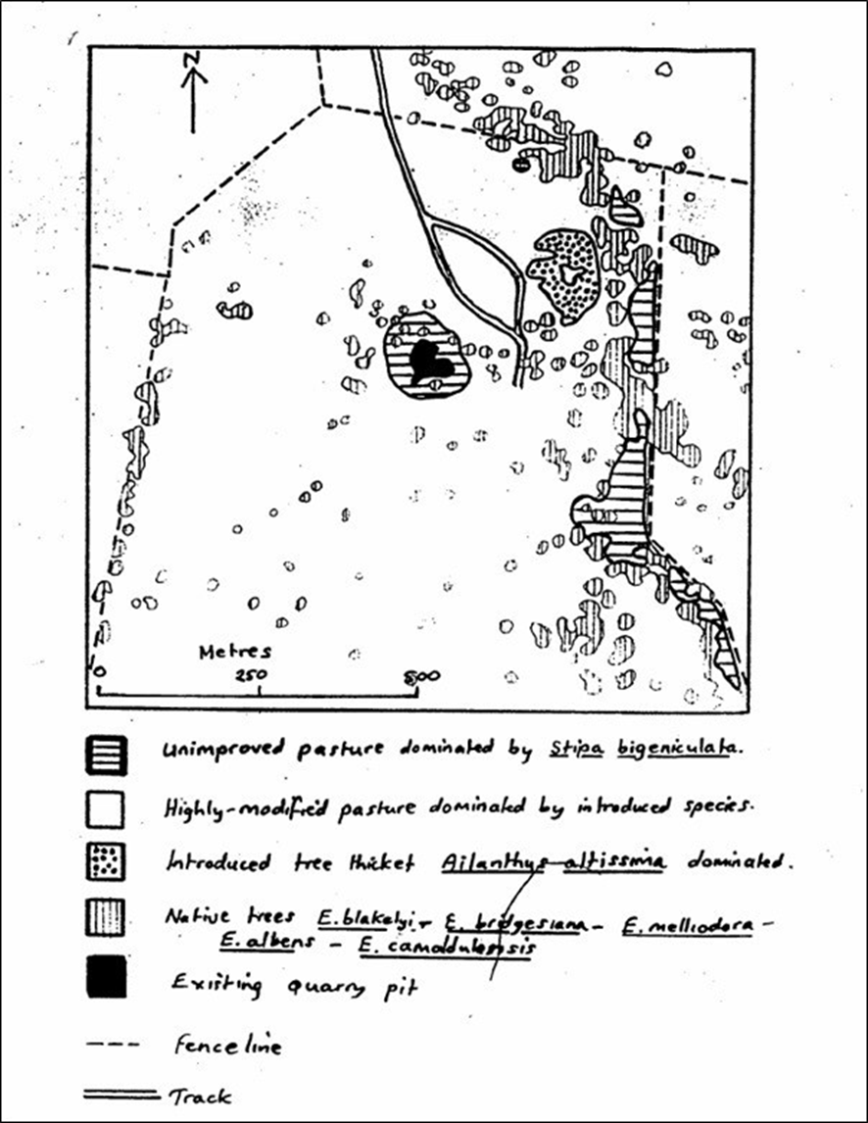

Appendix B – Water Retention, Chemical Storage and Possible Pollutants
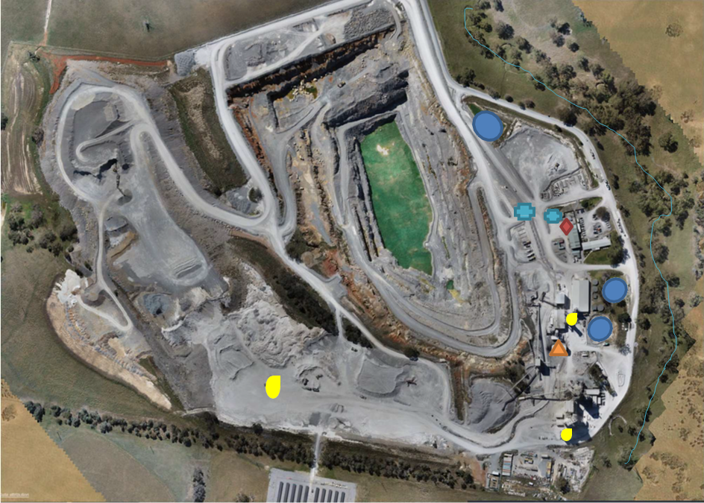

Settling / Catchment Ponds

Coal Shed  Oil Storage Shed
34,000l Diesel Tank 67,000l Diesel Tank
Limestone Creek

Appendix C – Areas Of Weeds
Source: Noxious Plants Certificate. Ref: Har_12449903. Southern Slopes Noxious Plants Authority. 24 November 2014.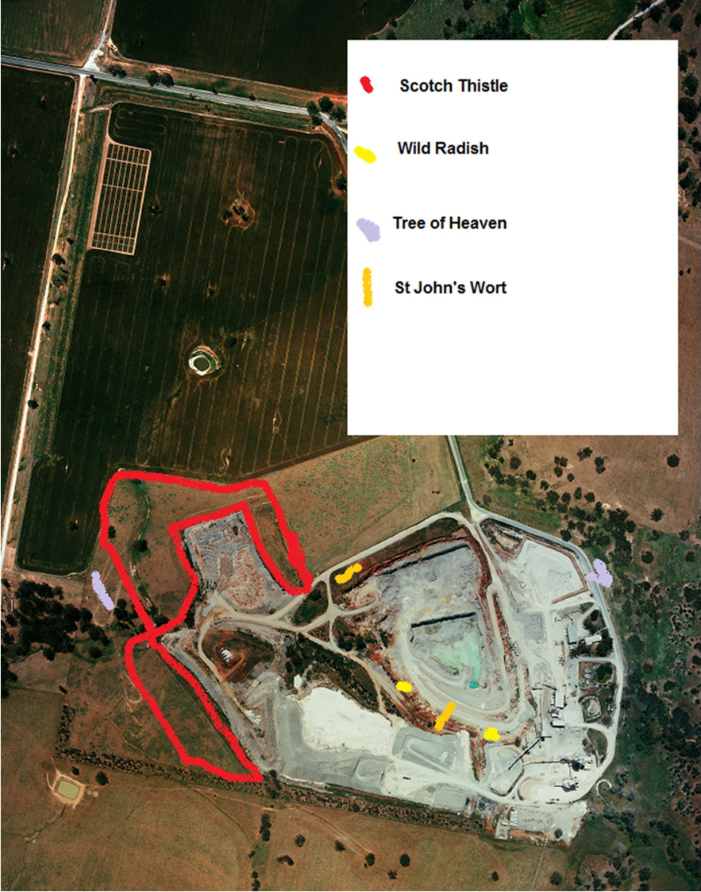

Appendix D – Site Plan
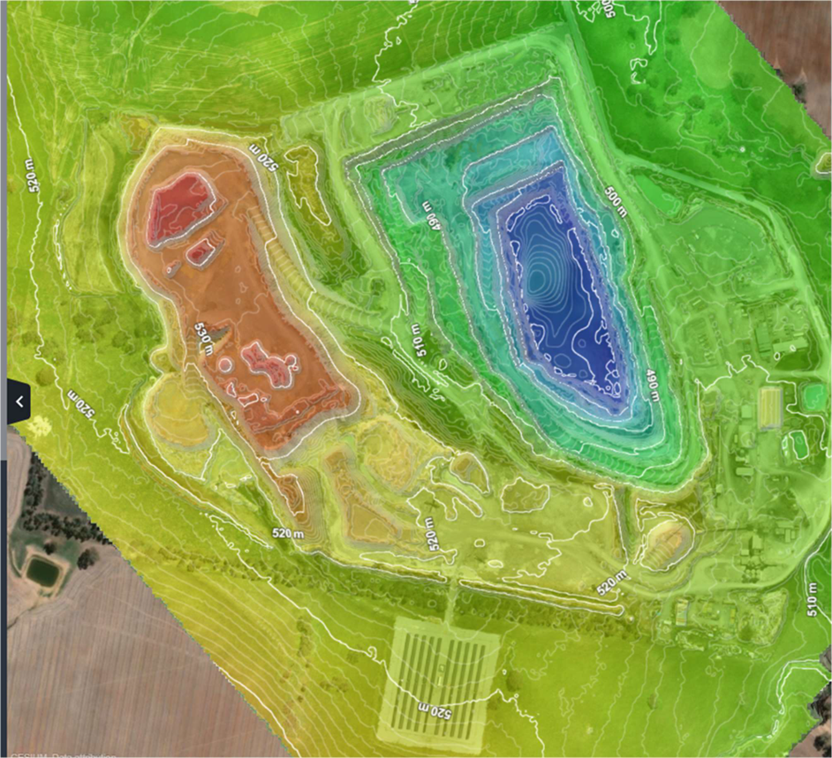

Appendix E – Monitoring Positions
Surface Water Monitoring Points
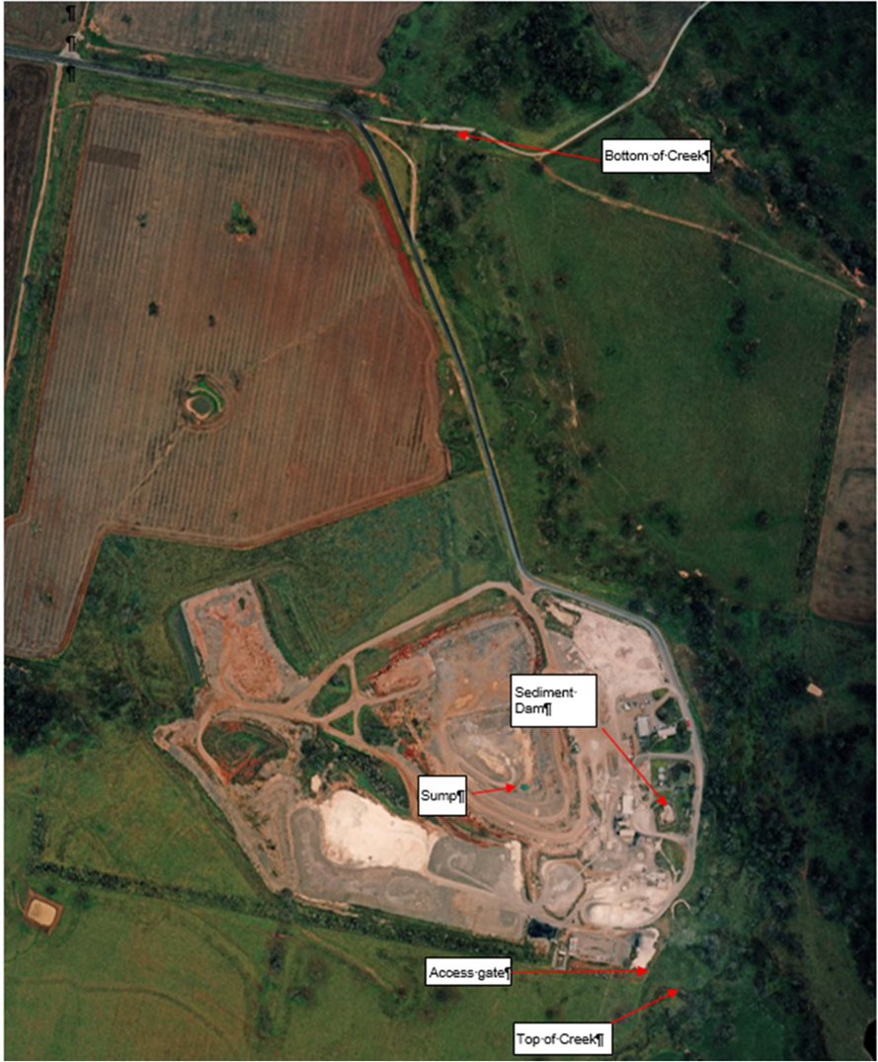

Dust Monitoring Points

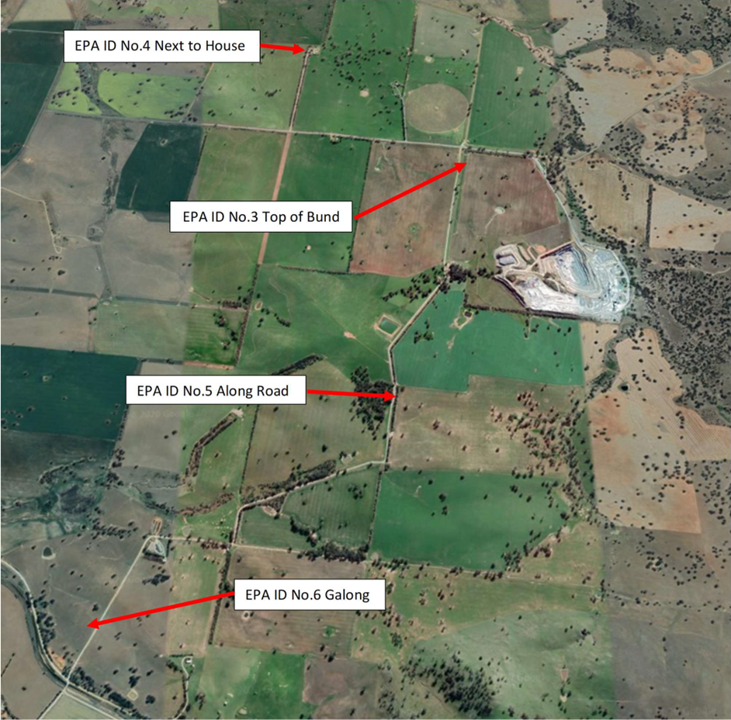

PIEZO Monitoring Points

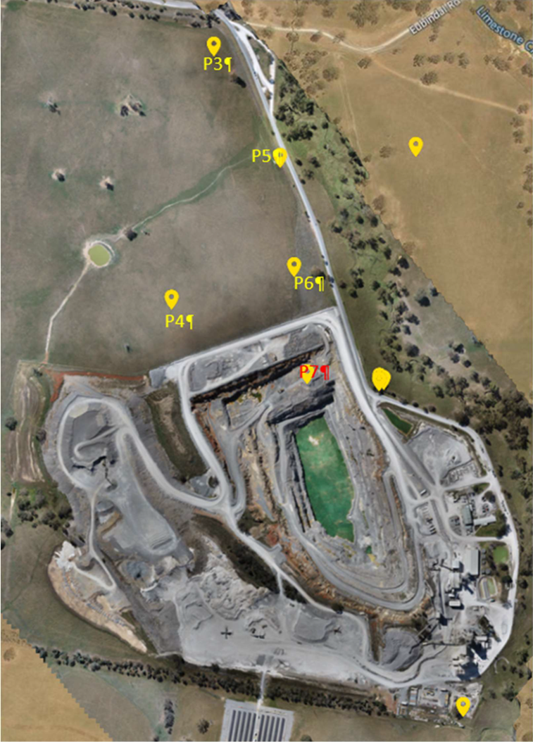

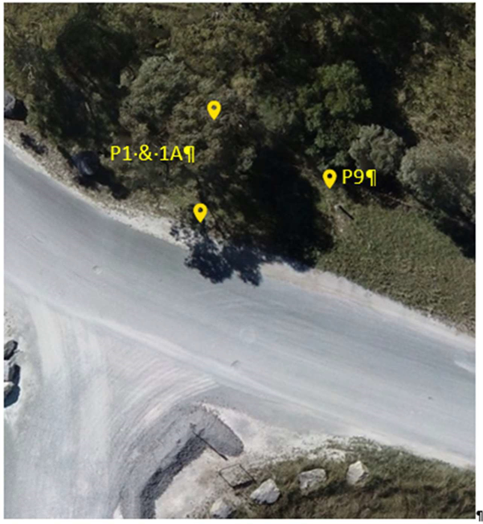

Riparian zone: An area where land and a watercourse interact, having an influence on one another.

